I
In the latest of our Explorations of Quaker texts series we looked at Isaac Penington's wonderful passage about forbearance, written in 1667: 'Our life is love, and peace, and tenderness; and bearing one with another, and forgiving one another, and not laying accusations one against another; but praying one for another, and helping one another up with a tender hand.' | 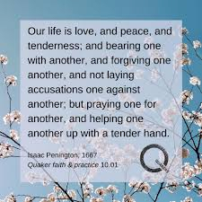
Isaac Penington wrote clearly, like a beacon, of his experience of the Inner Light. He spent half of his 22 years as a Quaker in prison, during the period of persecution after the Restoration. This much loved passage was written in Reading jail for his local meeting in Amersham, and remains an inspiration for Quakers, in how to respond to others in their meetings, their families, and their communities.
But nobody said it would be easy. Everyone present for the session felt Penington's message of love and forbearance was something to aspire to, to hope for, not to assume. It recalled ministry heard long ago: 'I come to Quaker meeting to become the person I want to be.'
How might we act on this message? Sometimes by mentally walking away from conflict, suppressing our anger; sometimes by engaging in dialogue; by being patient; by trying to find a personal connection. We would like our patience and tenderness (a rare word in early Quaker writing) to be recognised and rewarded but that might never happen, though a seed may be planted.
We can't always control our instant reactions, but we can recover from laying accusations against one another, by apologising. We can practise loving kindness in the spirit, by holding others in the Light or other forms of prayer.
And we can remember that in order to flourish and grow, sometimes we need to be challenged. Bracing or discomforting messages can be as important as emollient ones.

'
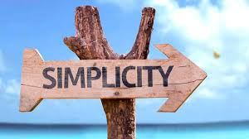
In the first of our Explorations of Quaker texts we looked at Advices & Queries 41: 'Try to live simply. A simple lifestyle freely chosen is a source of strength. Do not be persuaded into buying what you do not need or cannot afford. Do you keep yourself informed about the effects your style of living is having on the global economy and environment?
Living simply means focusing on what truly matters and letting go of unnecessary clutter, both physically and mentally. It’s not unique to Quakers; other traditions such as the Anabaptists give similar advice, but it can be quite hard to achieve.
We all felt we struggled to escape the clutter of modern life, whether it’s physical possessions, constant news updates, work commitments or personal obligations. It felt easier to start with physical decluttering—sorting through a lifetime of things—but we felt that can be surprisingly emotional, as some objects hold deep personal memories. Other objects are necessities of life and can’t be easily discarded. For example, an early Christian hermit might have thrived alone in a cave without the modern conveniences we take for granted, but a woman with small babies needs a certain amount of supplies. So perhaps when we’re trying to reduce physical clutter, we should be mindful of William Morris’s famous saying: ‘Have nothing in your house that you do not know to be useful or believe to be beautiful.’ And should we be challenging ourselves to consider how we might do more as a Quaker community to support one another to be less consumerist.
Freely choosing a simple lifestyle is a wholly different proposition, potentially connecting to the very essence of life? How can we make our lives less complicated? Can we focus more on experiences, ideas, art, music and the imagination instead of accumulating goods? Can we find a balance between being informed about the wider world and becoming obsessed with following the news.

